Utilities Try to Learn From Smart Meters
Vast customer data is starting to transform the ways companies operate – Rebecca Smith, WSJ, 22 Sep 2013
Utilities have installed more than 60 million smart meters in North America in the past decade.
Now they have to figure out what to do with all the information the devices are generating.
It's a mind-boggling amount of data. Consider that traditional meters did nothing more than track consumption. They were read 12 times a year by meter readers. In contrast, smart meters bombard utilities with data, often passing along meter readings every 15 minutes, or 35,000 times a year. They also alert utilities to electricity theft and dozens of other useful things.
And that's just part of the story. In addition to the smart meters, information is streaming in from the grid itself, where millions of sensors and smart controllers are giving utilities deeper, more timely information on equipment performance and power flows.
"The flow of data is increasing fast," says Matt Wakefield, director of information technologies for the industry-funded Electric Power Research Institute in Palo Alto, Calif. "The challenge [for the industry] is in understanding the opportunities. There's a gap in analytics."
Blame It on the Pump
As utilities get their arms around the data, the implications for consumers could be significant.
Enlarge Image
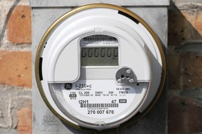
Close

Associated Press
A smart meter can send 35,000 meter readings a year.
"The increase in data has potential to revolutionize the way utilities interact with customers," says Guerry Waters, vice presidentof industry strategy for Oracle Utilities, a division of Oracle Corp., the big software company.
Val Jensen, senior vice president of customer operations at Chicago-based Commonwealth Edison Co., says his home in California recently was using abnormal amounts of electricity. With the help of his smart meter and local utility PG&E Corp., he learned that his pool pump was malfunctioning. Once fixed, his electricity bill dropped by about $100 a month.
Direct Energy, an electricity reseller, recently teamed up with data analytics company Opower to give some of the reseller's Texas customers extra information. If energy consumption is trending higher than desired levels, the customer gets an alert so he or she can take action.
Monte Beck, Direct Energy's chief marketing officer, says the company is also looking at opportunities to offer additional products and services, like efficient air conditioners to those that need them. "There are definitely cross-selling opportunities," he says, "but we're still early days."
The power industry "is where the retail industry was 25 years ago, when it was just beginning to use bar codes and scanners," says Ken Seiden, director of energy for Navigant Consulting Inc. Retailers initially saw scanners as a way to trim labor costs, but soon found the devices helped them sharpen inventories and provided new insights into consumer preferences. Mr. Seiden believes utilities will learn a great deal more about their customers as well, thanks to the meters.
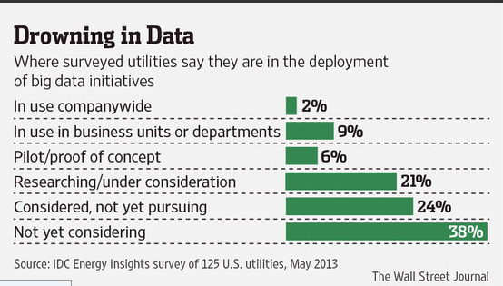
Meanwhile, utilities are also trying to get their arms around all the new information flowing from the grid. The Sacramento Municipal Utility District is using smarter equipment in the field to troubleshoot problems, making the service less dependent on crews. The change is speeding up the whole repair process, says Paul Lau, assistant general manager, "and is allowing us to give more timely information to customers."
Similarly, Hydro One Inc., a big Canadian utility, recently installed advanced sensors to help it pinpoint equipment in need of repair.
"We have $20 billion in assets," says Bruno Jesus, Hydro One's head of asset management. "We need to know which assets need attention before they fail." It now can ping individual pieces of equipment and find out how they're doing. "We avoid outages this way," says Mr. Jesus.
Instead of trying to develop these kinds of capabilities on their own, utilities are increasingly turning to outside parties. Some are big vendors, like Oracle, SAP AG and International Business Machines Corp. IBM's chief scientist, Lloyd Treinish, says he wants to help make the electric grid hardier, smarter and less costly. IBM sells a service that takes sensor data at wind farms and combines it with weather information and other data to predict the output of wind turbines. The objective: eliminate forecasting errors that make it hard to use wind resources to maximum effect.
Startups, too, are helping the big-data drive, like Space-Time Insight, which mashes together data from meters, network sensors, weather and utility records to give utilities more intelligence and greater control over their networks. When wildfires threaten power lines, for example, an electronic map designed by the company can show where winds are likely to push the flames.
"This is just the tip of the iceberg," says Steve Ehrlich, senior vice president of marketing at Space-Time. He says that the more tools his staff creates, the more utilities want.
No-Brainers, Too
Other vendors, like Boston-based Retroficiency Inc., have invented tools that make use of already available power-usage data to help customers cut their energy bills. One recent customer, Paul Benner, realized he had a problem soon after opening his winemaking and brewing supply store, the Cleveland Brew Shop, in Cleveland's trendy Tremont district last fall. He had budgeted $150 a month for utilities but was shocked when he got his first electricity and gas bills, which totaled $418.
One month later, he had the results of an energy audit by Retroficiency. The audit advised him to replace 60 light bulbs with more efficient versions, install fans and a programmable thermostat, and make some other adjustments. Spending $400 on upgrades cut his utility cost in half. "It was awesome," says Mr. Benner. "A complete no-brainer."
The audit was deceptively simple, and relied on relatively little information from the Brew House itself. Indeed, Retroficiency supplements site-specific information with data from tens of thousands of prior energy audits around the U.S., as well as performance data for equipment and building materials.
"Utilities spend $9 billion a year on energy-efficiency programs," says Bennett Fisher, founder and president of Retroficiency. "Their process of doing audits is very manual. We use data to make it more automated."

